Civil war in Somalia

UNSC Resolution: | 746
Date of adoption: | 17-Mar-1992
Operative paragraph: | 8
Demand number: | 746,0811

Sarah-Myriam Martin-Brûlé

Wording of demand

Respect fully the security and safety of the technical team and the personnel of the humanitarian organizations and guarantee their complete freedom of movement in and around Mogadishu and other parts of Somalia

List of addressees of the demand

Government of Somalia, United Somali Congress Faction

Short-term compliance

Description of the addressee(s)’ conduct

“The warlords' troops have fired missiles at ships ignoring their previous bans on use of the port, the most important entry for food to this famine-wracked nation.”
U.N. Urges Warlords to Open Somali Port
Sunday, November 22, 1992, on section 1 page 18 of the New York edition.
http://www.nytimes.com/1992/11/22/world/un-urges-warlords-to-open-somali-port.html

5. The difficulties of providing relief assistance under prevailing conditions in many parts of Somalia are evident and the safety of relief personnel engaged in humanitarian assistance remains a paramount concern. Nevertheless given the magnitude of the crisis and its threat to the stability of other countries within the Horn of Africa, no time can be lost in mounting large-scale relief efforts. In this regard, the paradox facing the international community should be noted: without security, relief assistance will continue to be severely constrained, but without relief assistance programmes, the prospects for security are at best precarious.
http://daccessdds.un.org/doc/UNDOC/GEN/N92/175/74/PDF/N9217574.pdf?OpenElement

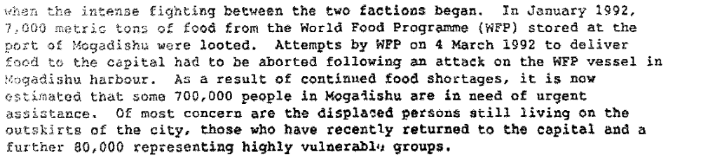
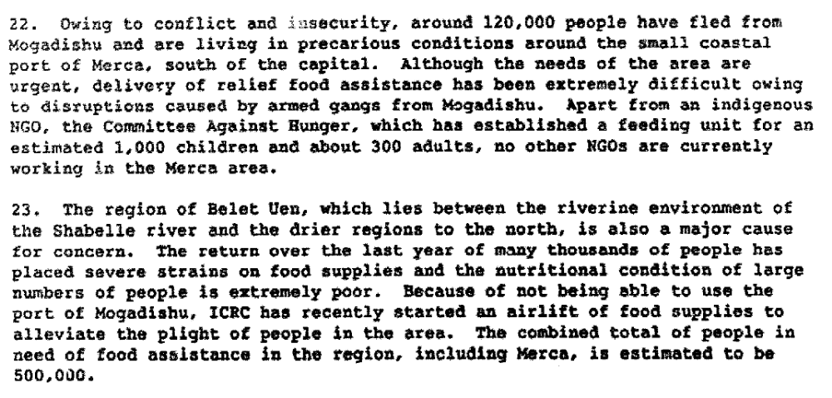
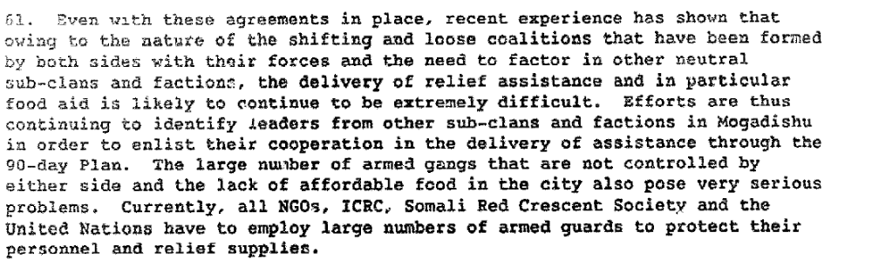
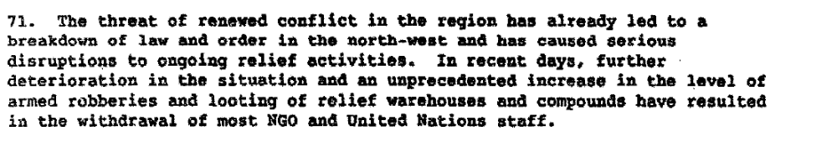
Report of the Secretary General on the Situation in Somalia, 21 April 1992 S/23829/.

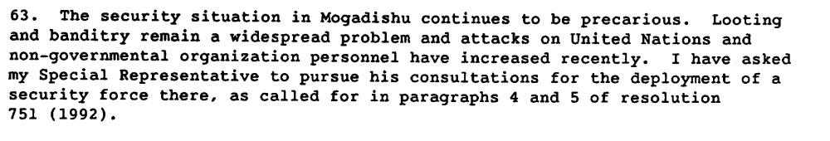
Report of the Secretary General on the Situation in Somalia, 22 July, 1992 S/24343/.

24. The north-west suffered grsatlp 5x3 the civil war. Its siain city,
tiargdsa, tmce ham tb wer 505,ObQ people, was abaadoaad by tb% population,
most of tb%za fleeing to sefngee camps in &tbfopia, Kenya aad Djibouti.
Although many of there p%ople have now rsturned , some 35 gar cent of homes and
pa&lie buil&fikga in the city were destroy%9 during aerial aad grouad
bombardment aad ac% ao longer habitable. Health care services, water systems,
schooas end saaStatfon service& as well as c ommnication aad banlting rrp~tems.
war% virtually wiped out tbtoughfmt the region. fn addition, buxu%raBso f
thausan&e of mine= wer% laid, partictiarly fa and around Raxgeiaa aad Burao.
Along 4th tb% vast emounta of unexploded ordnance, they remain a major risk
to the liv%s of both Sotnalis and relief workers.
25. In may ar%as of tbe north, the September-October

Assessment

Short-term compliance
X No or marginal compliance (1) | Medium low compliance (2) | Medium high compliance (3) | Full or almost full compliance (4)

Considerations underlying the assessment

Medium-term compliance

Description of the addressee(s)’ conduct

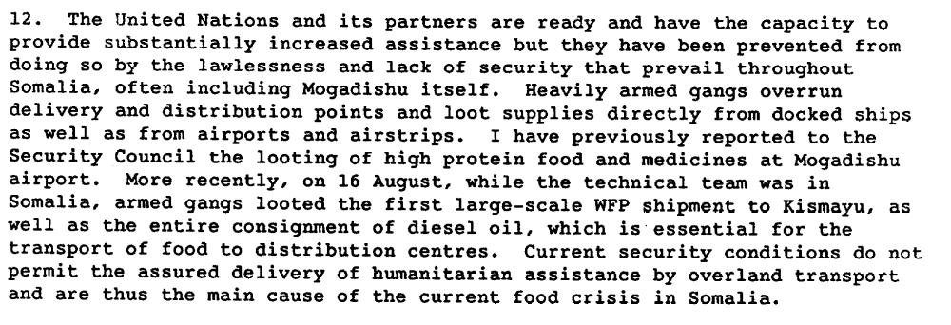
Report of the Secretary General on the Situation in Somalia, 24 August 1992 S/24480/.

All this, however, was bound to have implications for the role of aid organizations in the conflict. As one Canadian military officer said relief agencies 'got sucked into the clan wars in a big way. The relief aid agencies are part of the problem here, beginning with the self-induced rates of extortion they were paying and ending with the fact that, let's say through inexperience, they worked with one clan and not another. They chose sides. They did indeed have enemies.' Another study determined, 'donors' ongoing assistance - however often cut-offs were threatened - effectively fuelled the fighting, creating, in this sense, disincentives to peace.' Or, as yet another observer wrote, 'The heavy dependence of aid workers on local warlords in Somalia has arguably not only prolonged the conflict in providing all sides with the means to carry on their quarrels, but has also exacerbated it in the sense that old rivalries got reinforced.'[…]
Yet, in Somalia, the drive to relieve the famine (and, more cynically, the competition for resources and reportable successes among the aid agencies) led NGOs to forgo this option. The relief agencies instead opted for protection. They began by hiring guards for food distribution. After ICRC vehicles were looted and its workers robbed in 1991, the organization made the unprecedented decision to trade food, initially, and then currency, for protection. In one estimate, the ICRC paid up to $110 per month, plus food, to each guard it hired; and in Kismayo alone it hired hundreds of young men. CARE-US, similarly, was spending upwards of US$100,000 per month on guards. Indeed, most NGOs ultimately hired guards to protect their goods and personnel. Yet, hiring the guards enriched the power (and the coffers) of the warlords, for whom many of the guards worked. In addition, it had well-documented secondary effects which exacerbated the lawlessness in Mogadishu, including increased importation of small arms, the concomitant proliferation of guns in the cities, and the rise in crime as the 'guards' used their new weapons for robbery.
Taw, Jennifer Morrison(2004)'The Perils of Humanitarian Assistance in Armed Internal Conflicts: Somalia in the 1990s', Small Wars & Insurgencies,15:2,5 — 19
http://pdfserve.informaworld.com/32673_770885140_791393639.pdf

Assessment

Medium-term compliance
X No or marginal compliance (1) | Medium low compliance (2) | Medium high compliance (3) | Full or almost full compliance (4)

Considerations underlying the assessment

Depth of demand

Assessment

Level of depth of demand
Low depth of demand (1) | X Medium depth of demand (2) | High depth of demand (3)

Considerations underlying the assessment

Level of confidence about coding decisions

Level of confidence about coding decision
Extremely high | X High | Moderate

Comments to IPI (if any)

